Twitter - Analysis

Michael O'Brien

Thursday, July 02, 2015

## [1] "Using direct authentication"

## 4586 tweets have been parsed.

## 8262 tweets have been parsed.

## 2388 tweets have been parsed.

## 1719 tweets have been parsed.

## 3080 tweets have been parsed.

This is an introductory analysis of the twitter output of **UCC Business and Law, UCD Smurfit School, DCU Business School, Business at UL, JECairnesSchool NUIG** Business Schools and their twitter activity. A bit history of the twitter profiles is given

    

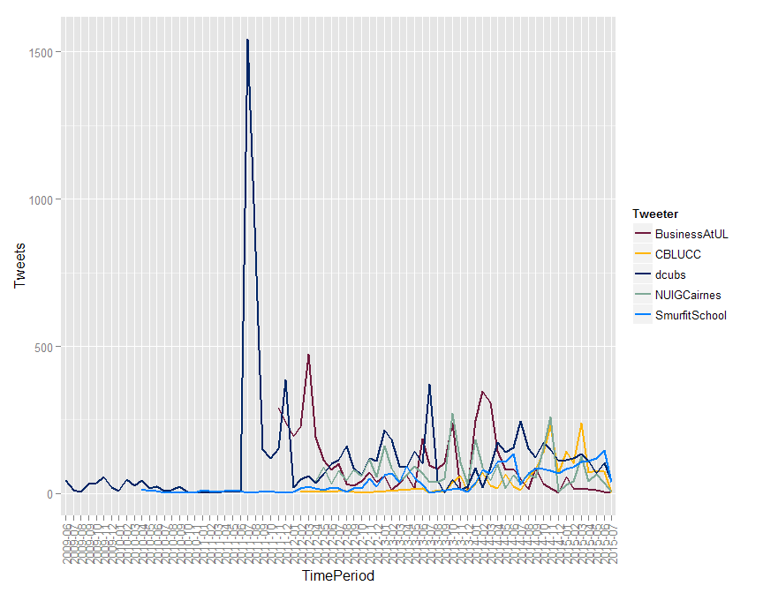

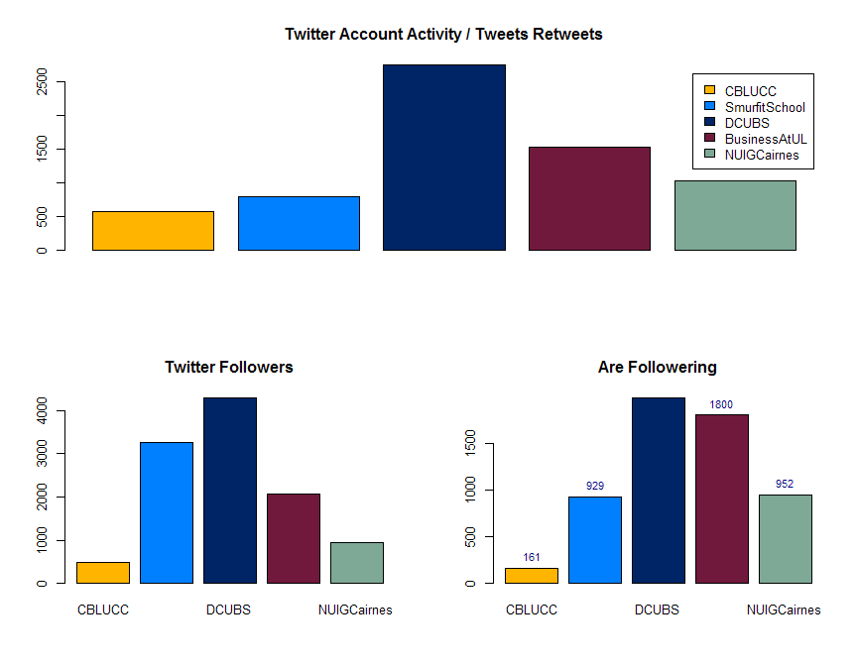

# Tweeting Activity

The plots below indicate the days of the week when each account is sending out tweets. The majority of activity is during the work week but some activity is recorded at weekends with DCU showing the most activity of Saturday and Sunday.

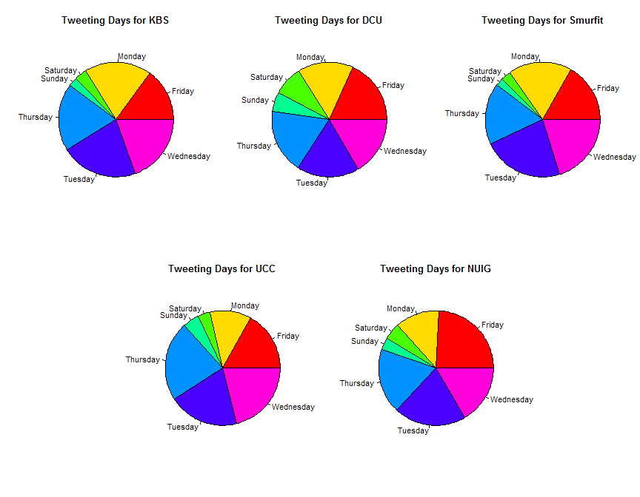

# Hash-Tags

In order to engage with the wider twitter communities and expand the reach of their message beyond followers its important to associate tweets with appropriate "hast-tags" so lets investigate the use of hash-tags a bit further. As we can see from the pie charts KBS is behind the other institutions when it comes to including tags in their messages but no institution is including tags in more than half their public messages.

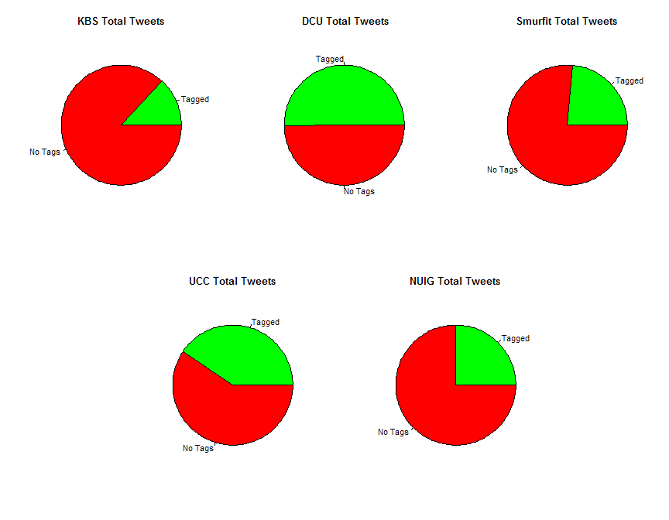

Of the tags that are used how varied and what topics to they cover? Lets visualise the tags in a word-cloud based on their frequency of use by each institution.

From left to right the tag clouds are KBS, DCU,Smurfit,UCC and NUIG. A common feature appears to be the use of regional tags and CAO related values. The most frequent KBS tags appear to be targeted at the institution itself instead of expanding the reach to more general business related discussions. This is contract to the Smurfit school where the most frequent tags include the #mba #scholarship and #education 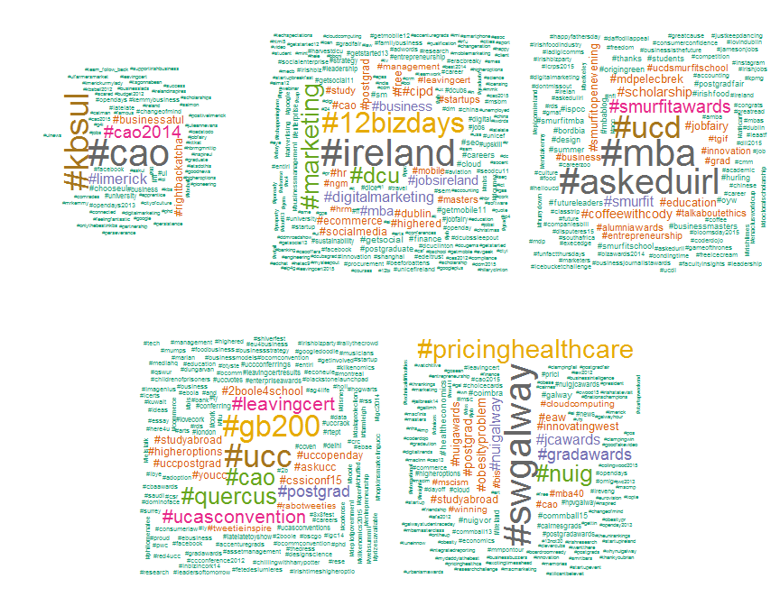

# Message Body

Finally lets turn to the contents of the tweets themselves and see what we can understand from the words used in the message body.

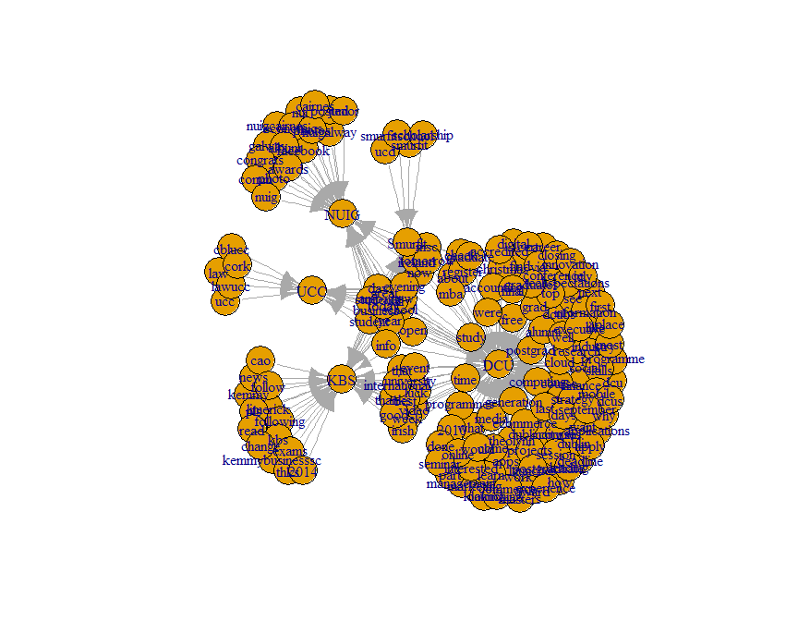

# Conclusions